**BOLLINGER BAND STRATEGY**

Bollinger bands strategy is a technical analysis strategy which was developed by John Bollinger in the 1980s. The band comprises of a volatility indicator that measures the high and low of a particular security price in relation to its historical trade prices.

The primary indicator which form the bases on which Bollinger Band strategy is developed is Moving Average(MA) and Volatility. Volatility in the strategy is measured by considering standard deviation of the historically traded prices.

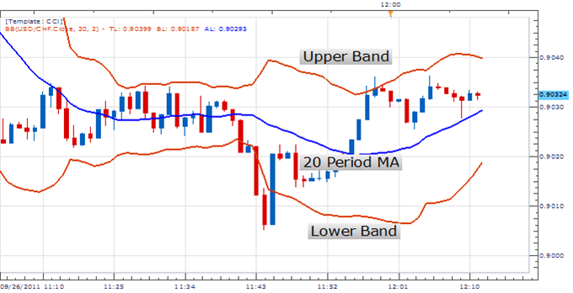

Bollinger Bands comprises of three lines – The Upper, Middle, and The Lower Band.

**The Upper Band** – Line that lies above the Middle Band. The value of the Upper Band depends on the trader in our strategy we have calculated Upper Band as 20 day Moving Average + (2 * standard deviation)

**Middle Band** – The middle band is nothing but the 20 day Moving Average.

**The Lower Band** – Similar to The Upper Band. The Lower Band lies below the Middle Band. It is calculated as 20 day Moving Average – (2 * standard deviation).

**Trading Strategies using Bollinger Band**

* Bollinger Bands are used to determine how strongly an asset price is rising and if there is a potential for reversal or losing strength.
* When the price is moving along the uptrend and is pushing above it indicates that price of the asset is pushing higher, and traders can exploit this opportunity.
* When the price is moving along the downtrend and is pushing below it indicates that price of the asset is pushing lower, and the trader are most likely to avoid trading.
* Generally, if the price of the asset remains between the middle band and the upper band, it indicates strong uptrend. However, if the price of the asset touches the lower band it is the sign for a reversal and an indication that the stock is losing strength.